Notes on Bone Fracture and Bone Repair

Classification of Fractures

- Position of bone ends after fracture.
- Nondisplaced fractures:

- Displaced Fractures:

- Completeness of break
a. Complete Fracture:

b. Incomplete Fracture:

- Orientation of the break
- Linear Fracture:

- Transverse:

- Whether bone ends penetrate the skin.
- Compound Fracture

- Closed (simple) Fracture

Comminuted Fractures
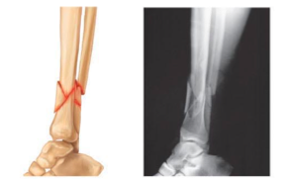

Spiral Fracture
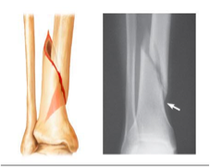

Depressed Fracture

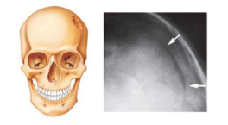

Compression Fracture

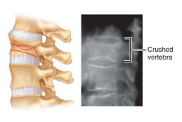

Epiphyseal Fracture

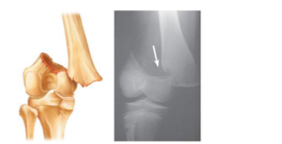

Greenstick Fracture

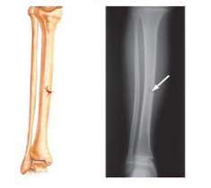
Bone Repair

Step 1 and 2

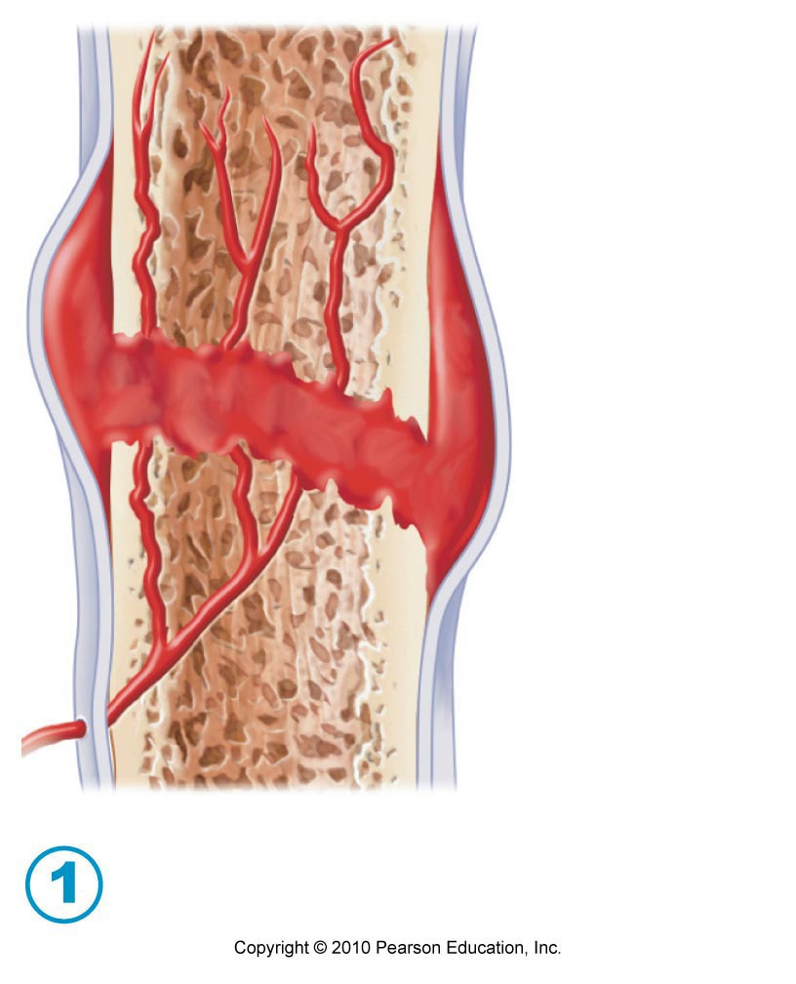
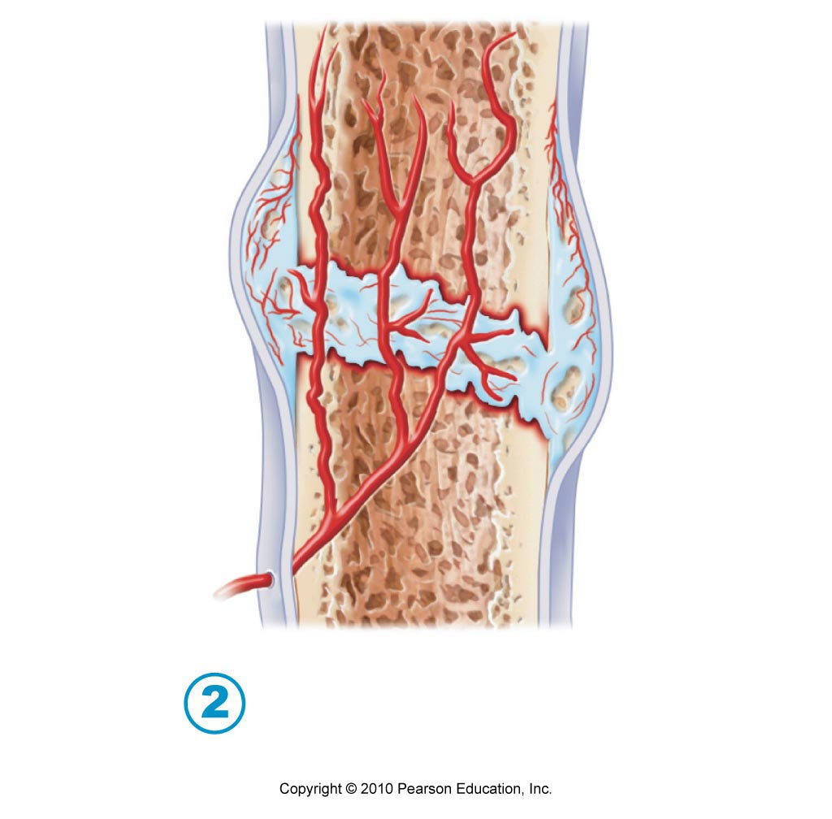

Step 3 and 4

