Dear Parent/Guardian,
We are writing to notify you of a new, online parent portal called OneView. OneView is where you will find the district’s annual student forms that previously would have been turned in on paper the first week of school. We are requesting that you take a moment to visit the OneView portal at https://lickingheightsoneview.esvportal.com/ and create your own account. There are instructions below to assist you in this process. Also, you will need to know your student’s ID number(s) since the student ID # will be referenced while creating your account.
Student Name:
Student ID #:
The electronic, online forms (Student Health Form, Emergency Contacts, etc) are available immediately. It would be very helpful if families could complete the online forms this week. However, we would like all forms completed and submitted by September 1, 2017.
If you have questions, please contact your individual school.
Thank you,
School Administration

Instructions for Creating an Account in OneView

- Click on the ‘Create A New Account’ | 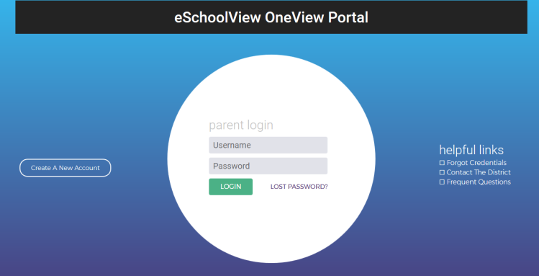
- Fill in the Personal Information  - Create your own  - Username and Password  - Security question/answer  - Pin Code  (Please create a username & password that you will be able to easily remember  for ongoing use. For example, use the same username and password that you already use to check your student’s grades in Parent Access) | 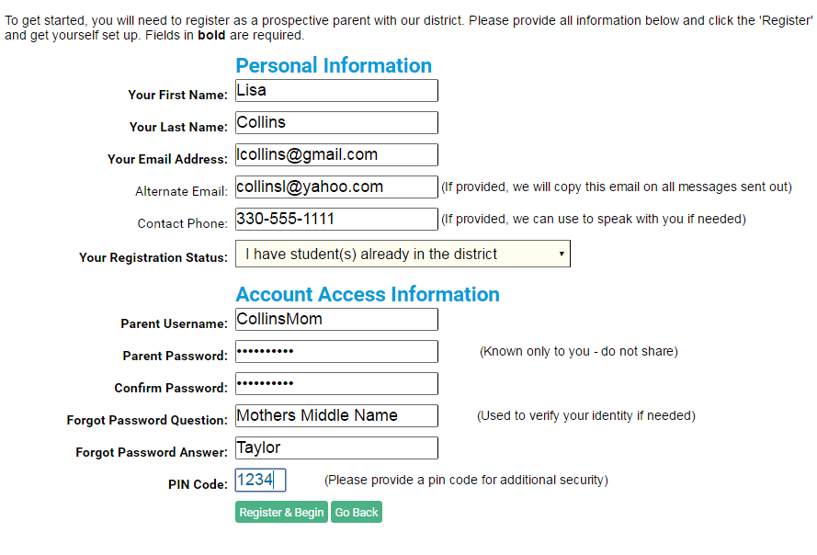
If provided by your district, Use “Option #1” to link your child to your account using the district-provided invitation code.  Use “Option #2: to link your child to your account based upon student data. You will need to use the Student Number(s) supplied on the opposite side of this paper after filling in the student Last Name, Grade Level and DOB. Click Attach. (Please note the Grade Level will be the current/upcoming grade level of the student for the new school year). | 