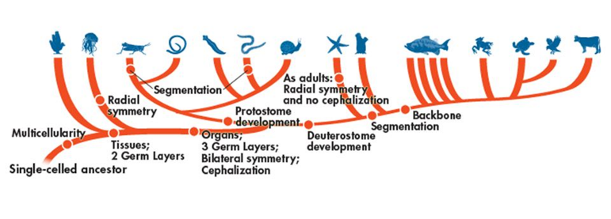

Domain:__________________________________

Kingdom:_________________________________

Phylum:__________________________________

*Fill out the following chart as you watch the Shape of Life video:* [Annelids: Powerful & Capable Worms](https://www.shapeoflife.org/video/annelids-powerful-and-capable-worms). *You can also find information on Annelida in your textbook (p. DOL 40-41).*

|  |  |
| --- | --- |
| **Body Plan** |  |
| **Feeding & Digestion** |  |
| **Circulation** |  |
| **Respiration** |  |
| **Excretion** |  |
| **Response** |  |
| **Movement** |  |
| **Reproduction** |  |

**Groups of Annelids**

*Focus on listing example organisms that belong to each group, where they are found, and their major characteristics.*

* Hirudinea 🡪
* Polychaeta 🡪
* Oligochaeta 🡪

**Anatomy of an Earthworm**

***\*See dissection packet for internal and external anatomy.***

**Life Cycle of an Earthworm**

