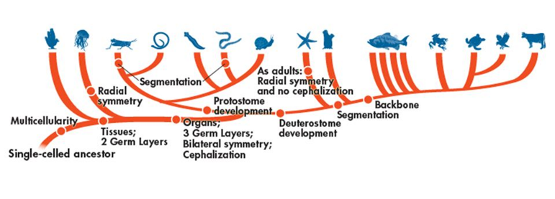

Domain:__________________________________

Kingdom:_________________________________

Phylum:__________________________________

*Fill out the following chart as you watch the Shape of Life videos:* [*Marine Arthropods: A Successful Design*](https://www.shapeoflife.org/video/marine-arthropods-successful-design) and [*Terrestrial Arthropods: The Conquerors*](https://www.shapeoflife.org/video/terrestrial-arthropods-conquerors). *You can also find information on Arthropods in your textbook (p. DOL 34-37).*

|  |  |
| --- | --- |
| **Body Plan** |  |
| **Feeding & Digestion** |  |
| **Circulation** |  |
| **Respiration** |  |
| **Excretion** |  |
| **Response** |  |
| **Movement** |  |
| **Reproduction** |  |

**Other Groups of Arthropods**

*Focus on listing example organisms that belong to each group and the characteristics that set them apart from the other two groups.*

* Chelicerata (Chilicerates) 🡪
  + Merostomata (Horseshoe crabs) 🡪
  + Arachnida (Arachnids) 🡪
* Uniramia (Uniramians) 🡪
  + Chilopoda (Centipedes) 🡪
  + Diplopoda (Millipedes) 🡪

**Anatomy of an Arthropod**

***\*See dissection packet for internal and external anatomy.***

**Life Cycle of a Grasshopper Life Cycle of a Crayfish**

