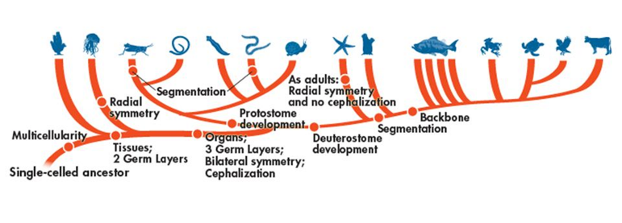

Domain:__________________________________

Kingdom:_________________________________

Phylum:__________________________________

*Fill out the following chart as you watch the Shape of Life video:* [*Cnidaria: Life on the Move*](https://www.shapeoflife.org/video/cnidarians-life-move)*. You can also find information on Cnidarians in your textbook (p. DOL 32-33).*

|  |  |
| --- | --- |
| **Body Plan** |  |
| **Feeding & Digestion** |  |
| **Circulation** |  |
| **Respiration** |  |
| **Excretion** |  |
| **Response** |  |
| **Movement** |  |
| **Reproduction** |  |

**Groups of Cnidarians**

*Focus on listing some example organisms that belong to each group.*

* Scyphozoa 🡪
* Anthozoa 🡪
* Hydrozoa 🡪

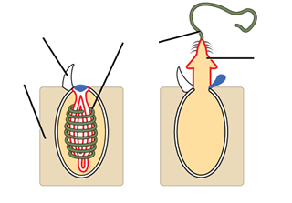**Anatomy of a Jellyfish**

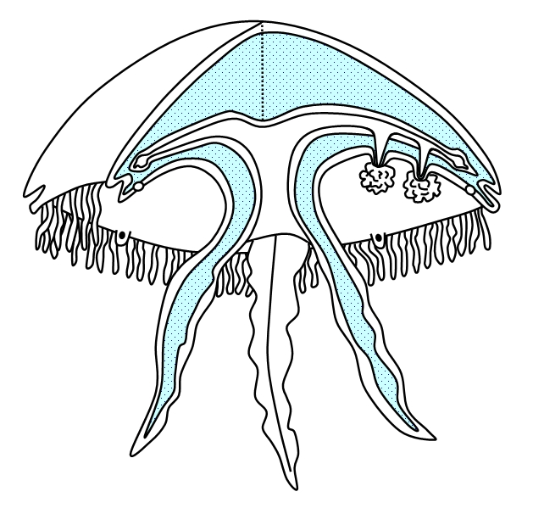

**Life Cycle of a Jellyfish**

