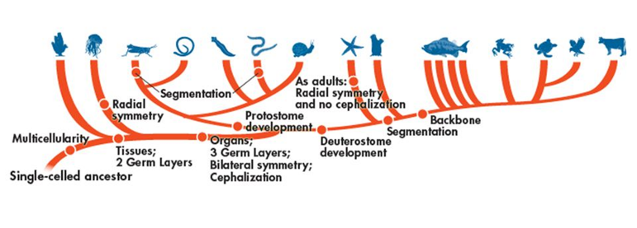

Domain:__________________________________

Kingdom:_________________________________

Phylum:__________________________________

*Fill out the following chart as you watch the Shape of Life video:* [Echinoderms: The Ultimate Animal](https://www.shapeoflife.org/video/echinoderms-ultimate-animal). *You can also find information on Echinoderms in your textbook (p. DOL 44-45).*

|  |  |
| --- | --- |
| **Body Plan** |  |
| **Feeding & Digestion** |  |
| **Circulation** |  |
| **Respiration** |  |
| **Excretion** |  |
| **Response** |  |
| **Movement** |  |
| **Reproduction** |  |

**Groups of Echinoderms**

*Focus on listing example organisms that belong to each group and their major characteristics.*

* Crinoidea 🡪
* Ophhiuroidea 🡪
* Asteroidea 🡪
* Echinooidea 🡪
* Holothuroidea 🡪