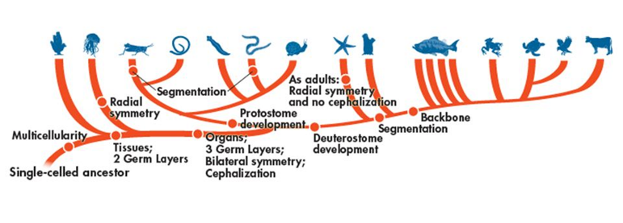

Domain:__________________________________

Kingdom:_________________________________

Phylum:__________________________________

*Fill out the following chart as you watch the Shape of Life video:* [Mollusks: The Survival Game](https://www.shapeoflife.org/video/molluscs-survival-game). *You can also find information on Mollusks in your textbook (p. DOL 42-43).*

|  |  |
| --- | --- |
| **Body Plan** |  |
| **Feeding & Digestion** |  |
| **Circulation** |  |
| **Respiration** |  |
| **Excretion** |  |
| **Response** |  |
| **Movement** |  |
| **Reproduction** |  |

**Groups of Mollusks**

*Focus on listing example organisms that belong to each group and the characteristics that set them apart from the other two groups.*

* Bivalvia 🡪
* Gastropoda 🡪
* Caphalopoda 🡪

**Anatomy of a Mollusk**



**Life Cycle of a Mollusk**

