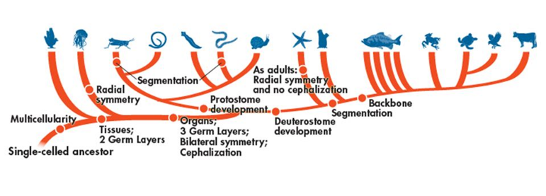

Domain:__________________________________

Kingdom:_________________________________

Phylum:__________________________________

*Fill out the following chart using the information on Nematodes in your textbook (p. DOL 38-39).*

|  |  |
| --- | --- |
| **Body Plan** |  |
| **Feeding & Digestion** |  |
| **Circulation** |  |
| **Respiration** |  |
| **Excretion** |  |
| **Response** |  |
| **Movement** |  |
| **Reproduction** |  |

**Groups of Nematodes**

*Focus on listing some example organisms that belong to each group.*

* Free living 🡪
* Parasitic 🡪

**Anatomy of a *Ascaris lumricoides***



**Life Cycle of *Ascaris lumricoides***

