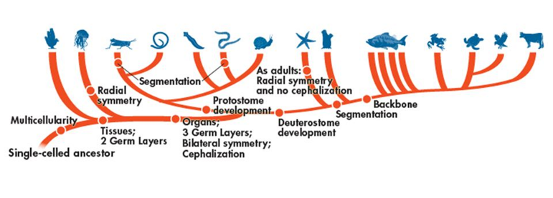

Domain:__________________________________

Kingdom:_________________________________

Phylum:__________________________________

*Fill out the following chart as you watch the Shape of Life video:* [*Flatworms: The First Hunter*](https://www.shapeoflife.org/video/flatworms-first-hunter)*. You can also find information on Platyhelminthes in your textbook (p. DOL 39).*

|  |  |
| --- | --- |
| **Body Plan** |  |
| **Feeding & Digestion** |  |
| **Circulation** |  |
| **Respiration** |  |
| **Excretion** |  |
| **Response** |  |
| **Movement** |  |
| **Reproduction** |  |

**Groups of Flatworms**

*Focus on listing example organisms that belong to each group and whether they are free-living or parasitic.*

* Trematoda 🡪
* Turbellaria 🡪
* Cestoda 🡪

**Anatomy of a Planarian**

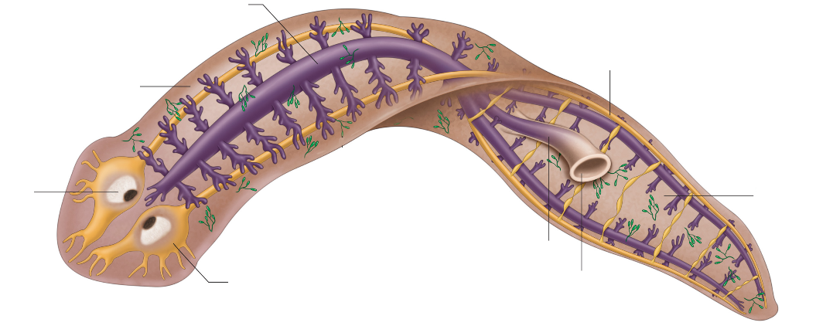

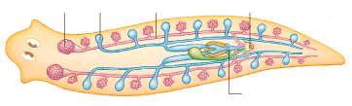

**Lifecycle of a Planarian**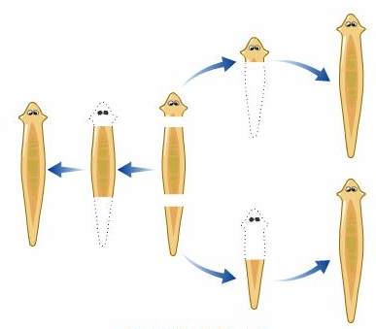

**Anatomy of *Taenia solium* (pork tapeworm)**

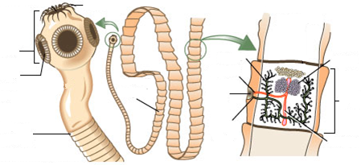

**Life Cycle of *Taenia solium* (pork tapeworm)**

