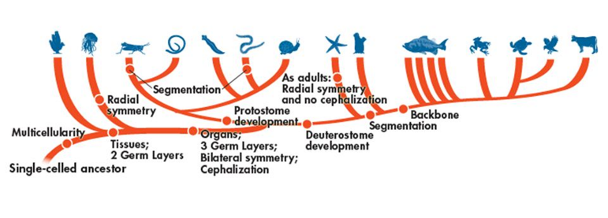

Domain:__________________________________

Kingdom:_________________________________

Phylum:__________________________________

*Fill out the following chart as you watch the Shape of Life video:* [*Sponges: Origins*](https://www.shapeoflife.org/video/sponges-origins)*. You can also find information on sponges in your textbook (p. DOL 30-31).*

|  |  |
| --- | --- |
| **Body Plan** |  |
| **Feeding & Digestion** |  |
| **Circulation** |  |
| **Respiration** |  |
| **Excretion** |  |
| **Response** |  |
| **Movement** |  |
| **Reproduction** |  |

**Groups of Sponges:**

*Make note of the type of substance each sponge uses to construct its “skeleton”.*

* Demospongiae 🡪
* Hexactinellida 🡪
* Calcarea 🡪

**Anatomy of a Sponge**

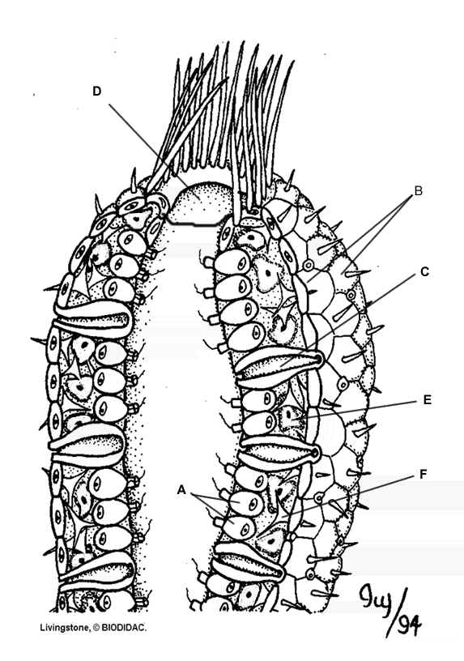

**Life Cycle of a Sponge**

