Central Pre-school
Pre-School Supply List

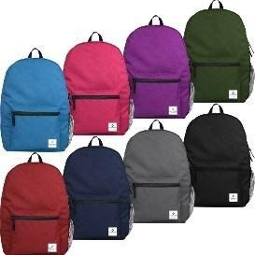  1 - Book Bag/Back Pack (No Wheels) | 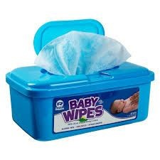  1 - Package of Hand or Baby Wipes | 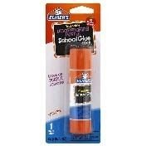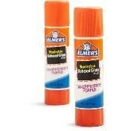  2 Giant OR 4 Small  Elmer’s Glue Sticks
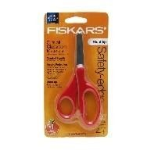  1 - Scissors (Blunt, Fiskars  Recommended) | 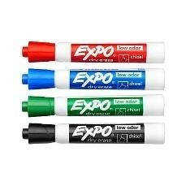  4 - Dry Erase Markers – Black (No  Skinny Markers) ** | 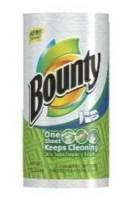  1 - Roll - Paper Towels
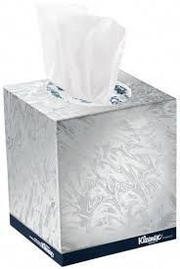  1- Box of tissues | 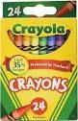  2- Boxes Crayons 24- count  (Crayola recommended, No Jumbo) | 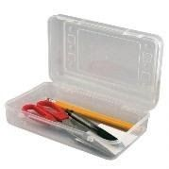  1 - Supply Box (Clear)
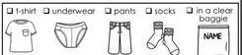  1- Change of clothes labeled with  Child’s name and in a bag labeled with  Child’s name  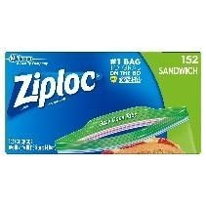  1 - Boxes Sandwich Size Bags – BOYS  ONLY | 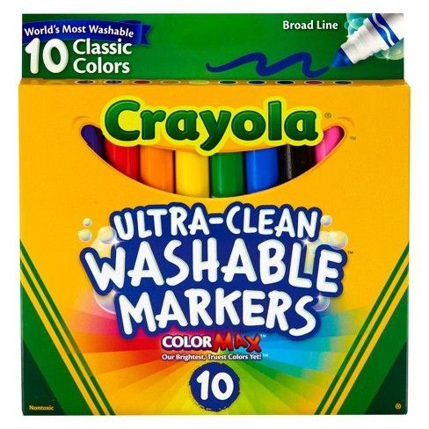  2-Boxes Washable Markers 10  Count  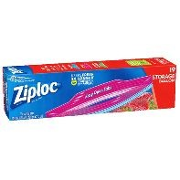  1 - Box - Gallon Size Bags GIRLS ONLY (Ziploc Recommended) | 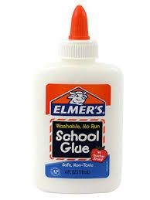  1- Bottle Glue  (Elmer’s 4 oz. recommended)  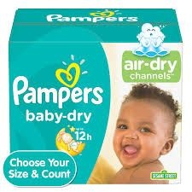  Diapers/Pull-ups with Velcro sides if needed
Optional items used that would be helpful to have:
1 Set Watercolor Paint, | 1 box colored pencils 12 count | 1 4-pack of Play Doh
1 pack non coated paper plates(small or large) 1 pack white or brown lunch bags

